SunSPOT Sample Project: ServoCar

Author: Yuting Zhang

Oct 02, 2012

1. Overview

This is a sample project of Remote-Control car using a pair of SunSPOTs, one Sun SPOT as a Controller and the other is OnCar. The Controller uses its tilt angles on two axes to remotely control the back/forth/left/right movements of the car, whose direction servo and electronic speed control (ESC) are connected by the SPOT OnCar. There are two movement programs and two speed options.

* Program 0:

|  |  |
| --- | --- |
| Controller Tilt | Car Movement |
| Forward | Forward |
| Backward | Backward |
| Left | Left |
| Right | Right |
| No tilt | Stop |

* Program 1:

|  |  |
| --- | --- |
| Controller Tilt | Car Movement |
| Forward | Backward |
| Backward | Forward |
| Left | Right |
| Right | Left |
| No tilt | Stop |

* Low speed
* High speed

The ServoCar project consists of two parts.

* ServoSPOT-Controller

This application runs on the Controller Sun SPOT periodically sampling the tilt angles by the built-in bi-axial accelerometer and sending xtilt and ytilt readings to its buddy, the SunSPOT OnCar, over the radio.

* ServoSPOT-OnCar

This application runs on a SunSPOT OnCar periodically receiving radio datagram from the controller, and drive the direction servo and ESC through a simple circuit on the breakout breadboard.

1. Steps for building and running the sample project

* ServoSPOT-Controller

1. Edit the *..\ServoSPOT-Controller\resources\META-INF\MANIFEST.MF* file.

Change the variable *buddyAddress* to the MAC address of the Sun SPOT OnCar.

Save and close the MANIFEST.MF file.

1. Open the *ServoSPOT-Controller* application in Netbeans

Build and deploy to the Controller Sun SPOT.

* ServoSPOT-OnCar

1. Edit the *..\ServoSPOT-* *OnCar\resources\META-INF\MANIFEST.MF* file.

Change the variable *buddyAddress* to the MAC address of the Controller Sun SPOT.

Save and close the MANIFEST.MF file.

1. Open the *ServoSPOT- OnCar* application in Netbeans

Build and deploy to the Sun SPOT OnCar.

1. Steps to connect the Sun SPOT OnCar
2. Connect the Sun SPOT OnCar and the breadboard via the ribbon cable.
3. Connect Vh and Vcc on the breadboard.
4. Connect the direction servo and ESC respectively
   * Direction servo’s 3 pins:
     + Black - GND
     + Red – Vh
     + White – H1 pin
   * ESC’s 3 pins:
     + Black – GND
     + Red – Vh
     + White – H0 pin

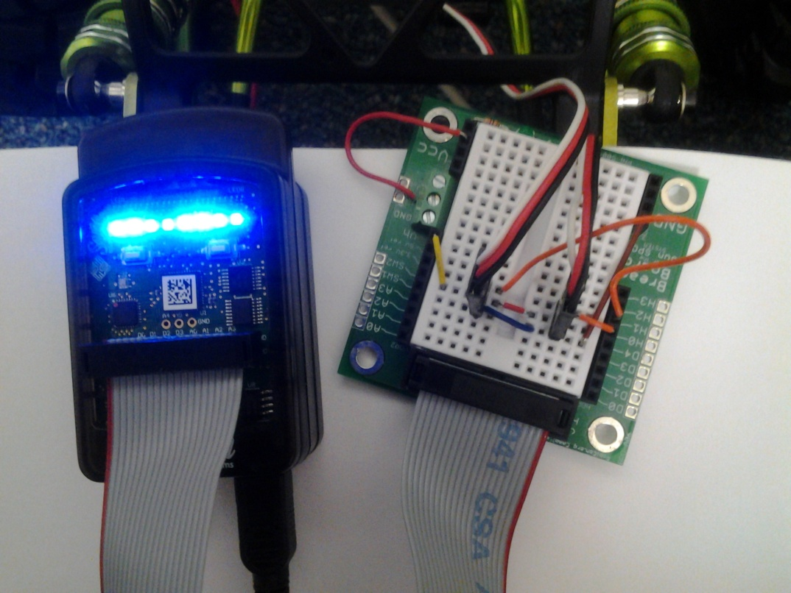

Note: the rechargeable battery on the car is 7.2V and internally connected to the ESC’s red pin. Do NOT use other external battery to power the ESC.

1. Drive the car
2. Press the reset button on the Controller and OnCar Sun SPOT. During application initialization, green flashlight shows up on both.
3. Radio connection state:

After initialization, the flashlights will indicate the radio connection

* Controller
  + Red: does Not connect with the buddy Sun SPOT OnCar
  + Blue: connect with the buddy SPOT OnCar
* Sun SPOT OnCar
  + Red: does Not connect with the buddy Controller
  + Otherwise: connect with the buddy Controller, indicate program and speed status.

1. Program selection:

Two programs can be switched by pressing the sw1 on the SPOT OnCar.

* Program 0:

Indication: LED 1 – 4 in Blue.

|  |  |
| --- | --- |
| Controller Tilt | Car Movement |
| Forward | Forward |
| Backward | Backward |
| Left | Left |
| Right | Right |
| No tilt | Stop |

* Program 1:

Indication: LED 1 – 4 in Green.

|  |  |
| --- | --- |
| Controller Tilt | Car Movement |
| Forward | Backward |
| Backward | Forward |
| Left | Right |
| Right | Left |
| No tilt | Stop |

1. Speed selection:

Two speeds can be switched by pressing the sw2 on the SPOT OnCar.

* Low speed

Indication: LED 5 – 8 in Blue.

* High speed

Indication: LED 5 – 8 in Green.